Dear Trumpet/Cornet players & parents,

Hooray for an instrument that doesn’t require lots of dollars to maintain. Other than the valve oil, slide grease, and cleaning snake – it’s an “insert mouthpiece and play” kind of instrument! As your son/daughter progresses through their junior high and high school years, it will be very valuable to begin purchasing trumpet mutes for the various sound effects we might produce in different compositions. Most music stores carry these mutes, however, you can definitely get a better price online. The most needed mute for all of our trumpet players is the straight mute (listed first). There are several shapes for the straight mute and any would be fine. The other mutes are ones that may occasionally be needed or are just listed for your own enjoyment. It is NOT necessary to purchase all of these for band. Please strongly consider the straight mute, however, as I only have a limited number of my personal mutes available to borrow.
Thanks! Michelle Floering 231-932-6008
STRAIGHT MUTES: 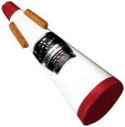 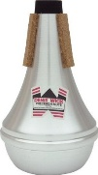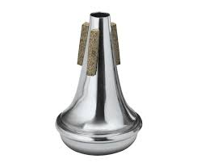If buying a used one, make sure the corks are in good shape (otherwise it will just fall out.)

CUP MUTE: 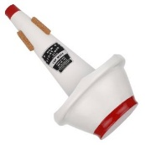 Check corks on this if it’s used also.
HARMON MUTE: 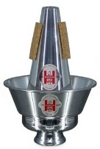 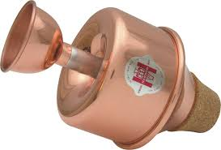This is played mostly with the plunger piece pulled out, so if you find a used one without the plunger – that’s okay.
Speaking of plungers…
PLUNGER: 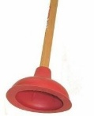Take off the end of an unused SINK plunger – get one of these for sure. They are fun!

BUCKET MUTE: 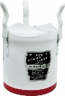 Probably won’t use in concert band. Can get a similar effect by playing your instrument closely into the stand.

WHISPER MUTE: 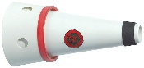 Not used in band, but might be helpful if you want to practice without anyone hearing you. Parents might find this helpful.

HAT MUTE: 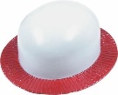 (Yep – it’s just a hat.)

